**2.1**

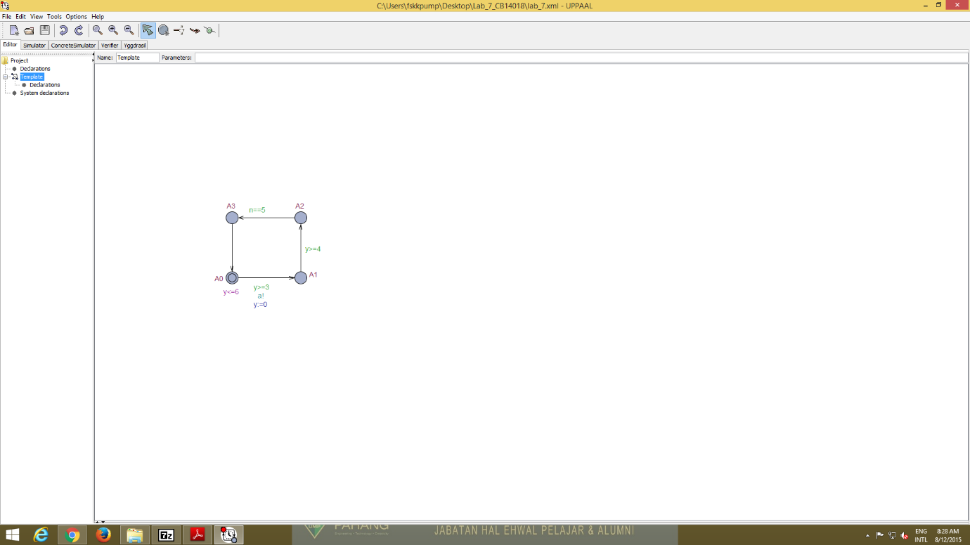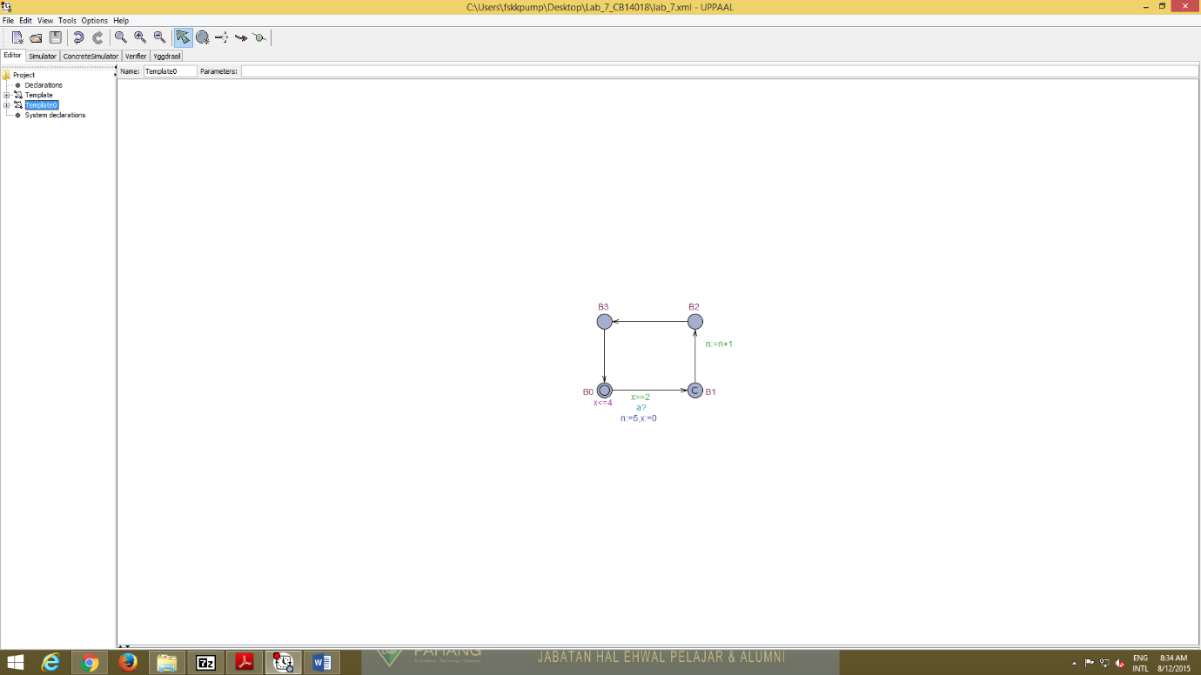

**2.2** The property to check the delayed transition is E<> y==3 or E<> y==3 and y>2 because the nodes cannot be more 4 times and time may elapse 3.5 units.

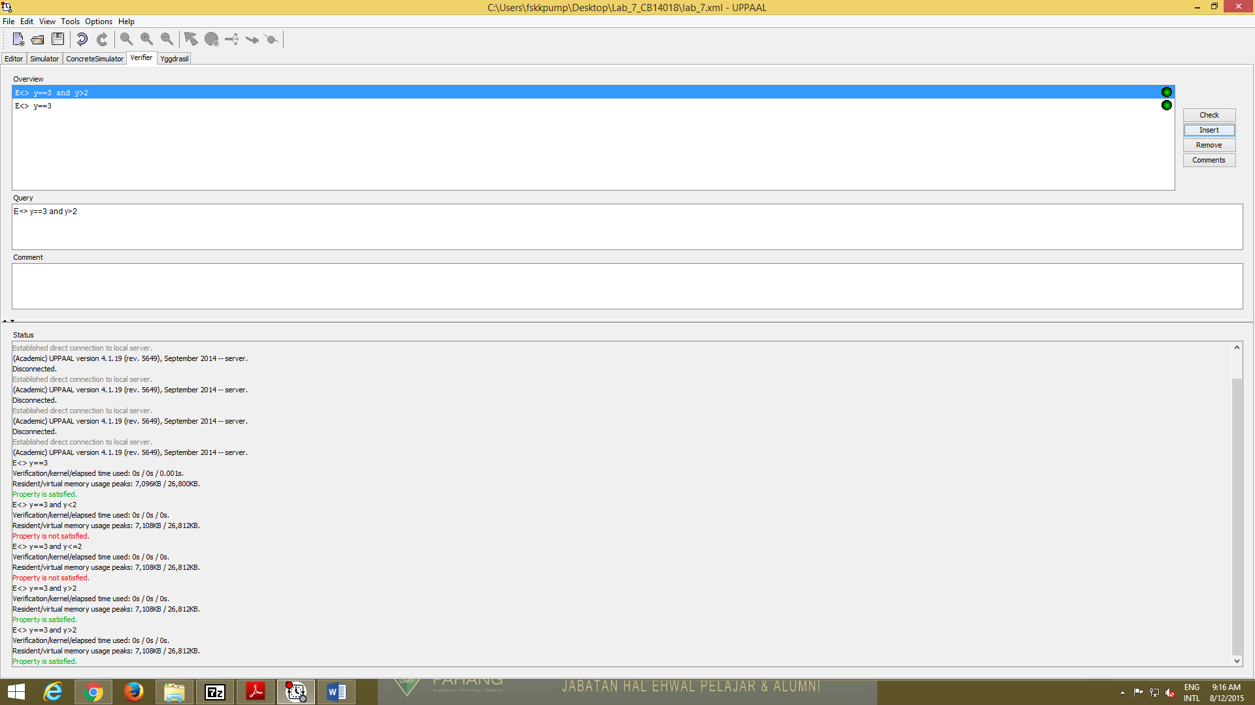

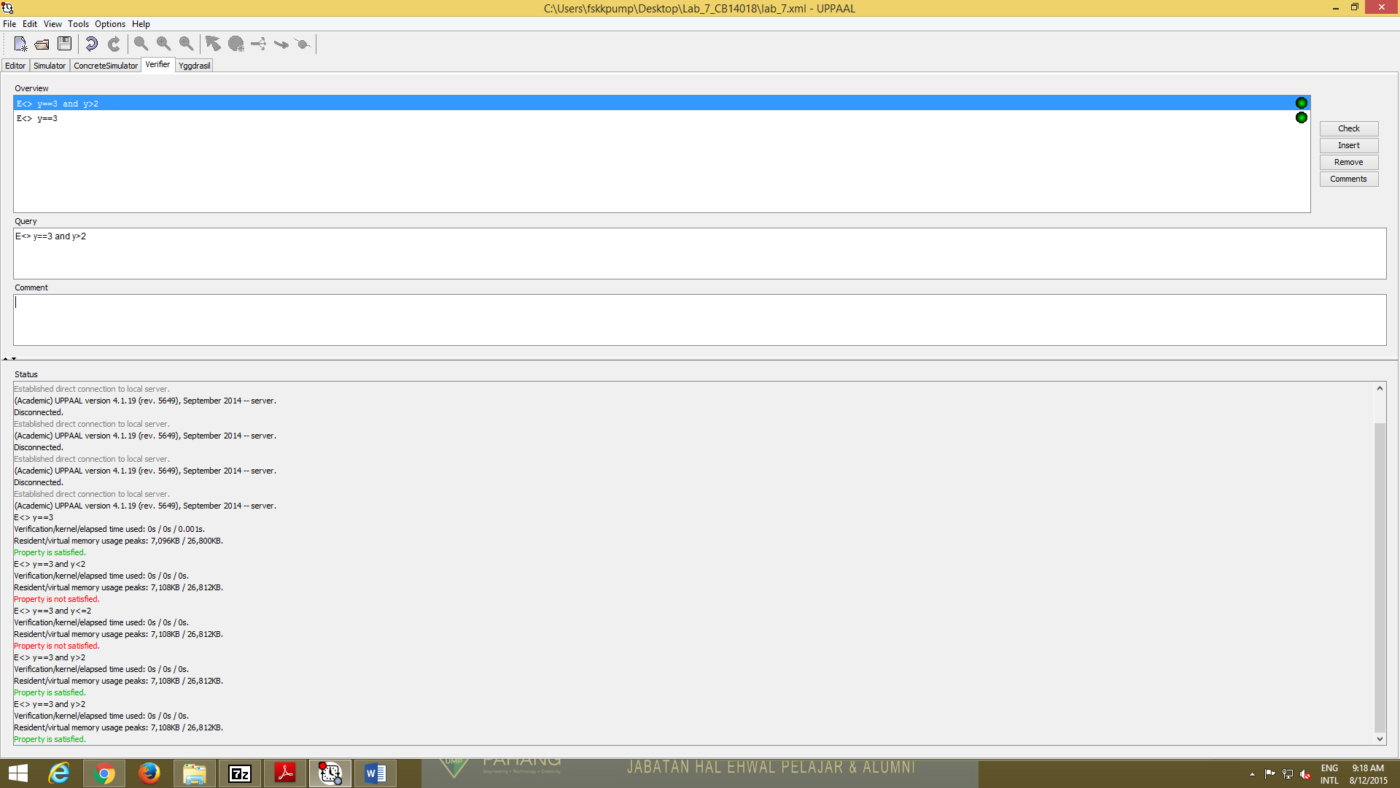

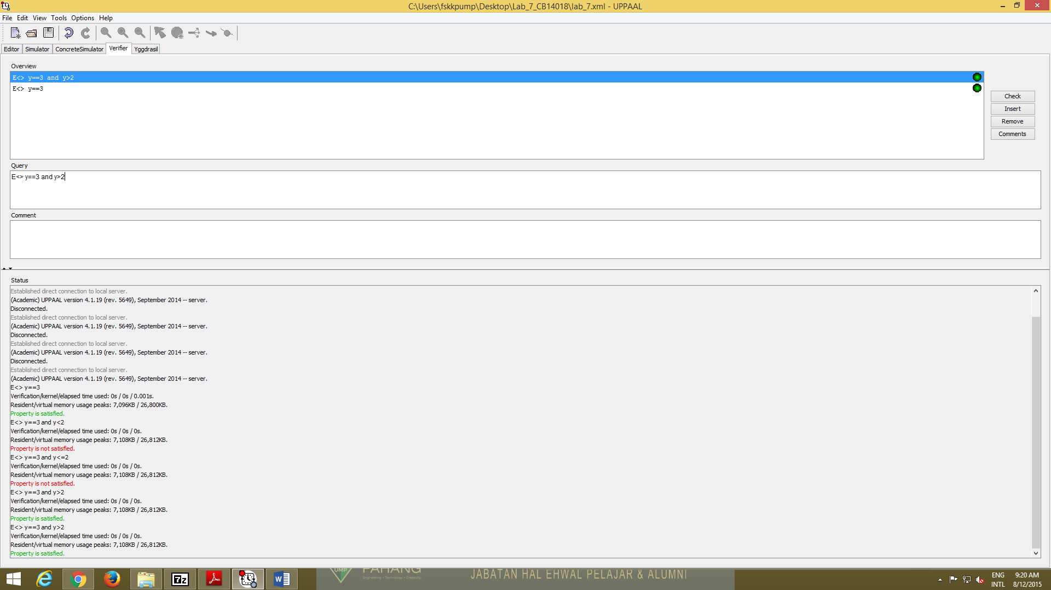

**2.3** To check the synchronised transition from two complementary edges of two different processes are enabled in a state then the two process can synchronize like A0 to A1 but it have a condition of y>=3 and B0 to B1 but it condition X>=2.

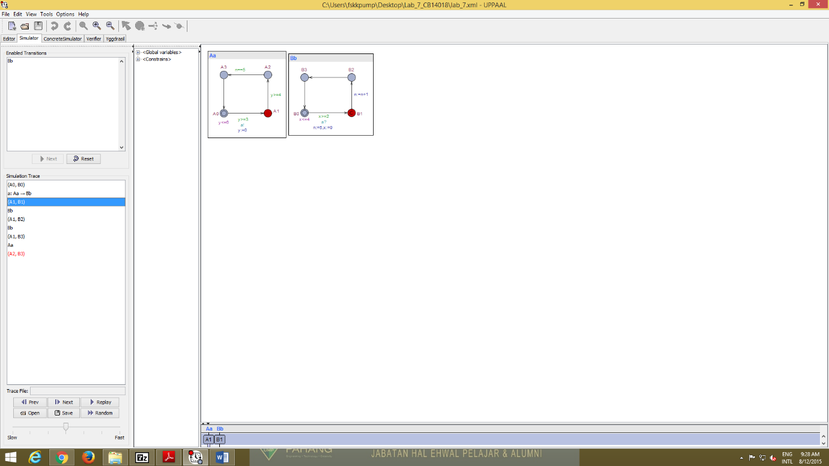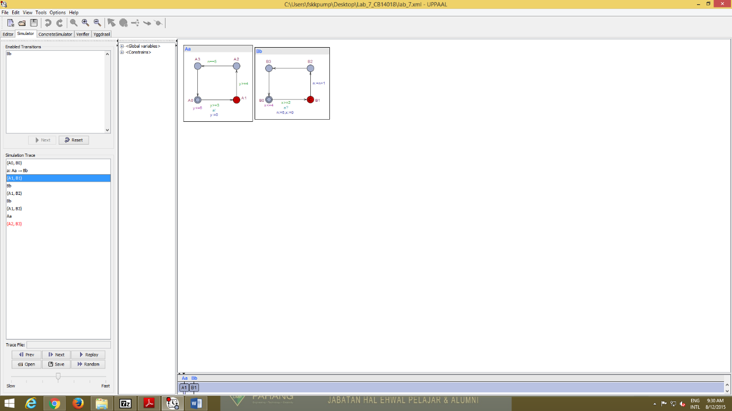

**2.4** If the Chan redefine as an urgent channel in A1 no further delay is allowed and it will only remain in A1 because synchronization on the channel is enabled but time could not elapse beyond 3.

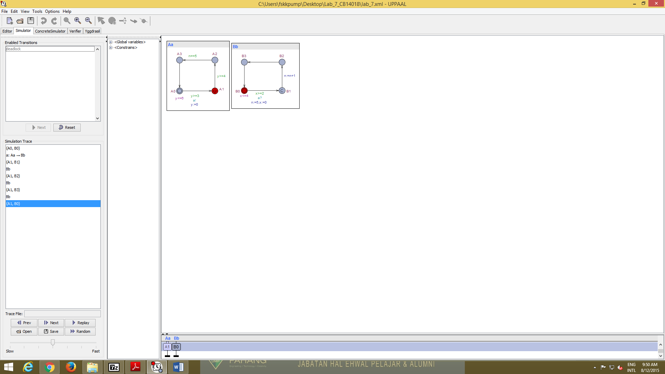

**2.5** If one of the components is in committed node all the process have no delay and all transition will involve in the committed node but the delay will happen and one transition that is A2 will remain in it node because in A2 the condition is n==5 but real condition is n==6 or n<6.

